YEAR 11 GENERAL HUMAN BIOLOGY

DO NOT MARK THIS BOOKLET

Multiple Choice 15 Marks

Short Answer 25 Marks

Total 40 Marks

Task 5: Reproduction, Pregnancy and Birth Test

Part 1: Multiple Choice (15 marks)

1 Which of the following are secondary sexual characteristics of the human male?  
  
a. Development of ovaries.

1. Hair growth around genitalia.
2. Breast development.
3. Development of testes.

2. A zygote is formed after the union of two:

1. ova.
2. gametes.
3. germ cells.
4. spermatocytes.

3. Which of the following is NOT a sign of early pregnancy?

1. Morning sickness.
2. Abdominal swelling.
3. Absence of menstrual periods.
4. Breast swelling and tenderness.

4. The advantage of the testes being suspended outside the body in the scrotum is they are:

1. better protected.
2. kept free from antibodies produced by the lymphatic system.
3. at a suitable temperature for sperm production.
4. given better support during exercise.

5. Which hormone is responsible for the production of breast milk?

1. Progesterone.
2. Prolactin.
3. Oxytocin.
4. Oestrogen.

*The next two questions refer to the following diagram.*

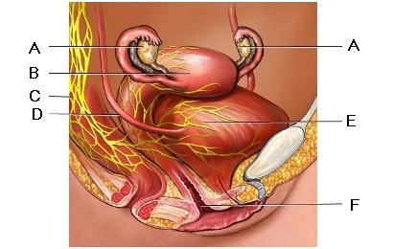

6. Production of ova occurs in:

1. A.
2. B.
3. E.
4. F.

7. Implantation of the blastocyst occurs in:

1. A.
2. B.
3. D.
4. E.

8. What hormone causes ovulation?

1. Follicle stimulating hormone.
2. Lutenising hormone.
3. Progesterone.
4. Human chorionic gonadotropin.

*The next three questions refer to the following diagram.*

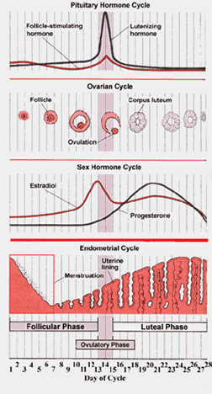

9. Fertilization could occur on days:

1. 1 – 5.
2. 9 – 14.
3. 14 – 19.
4. 24 – 28.

10. On which day did menstruation commence?

1. Day 1.
2. Day 5.
3. Day 14.
4. Day 28.

11. What is NOT a reason for inducing labour?

1. High blood pressure.
2. Bleeding.
3. A pregnancy that has gone longer than 42 weeks.
4. Breech presentation.

12. The third stage of labour includes:

1. the placenta, amnion and chorion being expelled.
2. bursting of the amniotic membrane.
3. full dilation of the cervix.
4. the foetus moving further down into the pelvis.

13. An ectopic pregnancy is one in which:

1. the embryo or foetus is spontaneously aborted.
2. many factors including poor nutrition, hypertension or endocrine imbalances cause swelling of the mother’s feet, face and legs.
3. there is increased vaginal discharge due to additional secretions from glands of the cervix.
4. the blastocyst implants at a site other than the uterus, possibly rupturing the fallopian tube as the embryo grows.
5. A natural method of contraception is
6. condoms
7. IUD’s
8. rhythm method
9. spermacides

|  |  |  |
| --- | --- | --- |
| **15** | What is the purpose of the umbilical cord? | |
|  |  | 1. It tethers the foetus to the uterine wall so it the foetus isn't born too early |
|  |  | 1. It supplies the foetus with oxygen and nutrients and takes waste products away |
|  |  | 1. When the umbilical cord is cut after the foeus is born, it becomes the belly button |
|  |  | 1. It could wrap around the baby's neck during birth |

END OF MULTIPLE CHOICE SECTION

SHORT ANSWER (Answer on lined paper)

pixel

*The next three questions refer to the diagram below.*

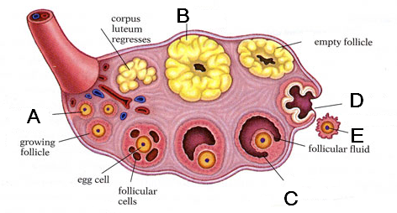

1. a. What event does E represent? (1 mark)

b. Name the hormone which causes this event? (1 marks)

2. Referring to the following diagram to answer the questions below.

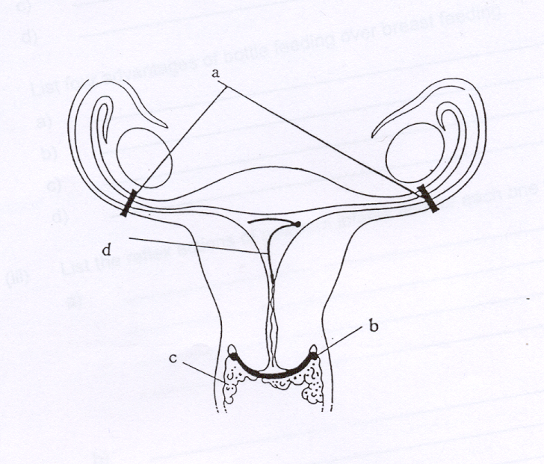

Name each method of contraception indicated by the letters and explain how they work.

d

(4 marks)

3. The diagram below illustrates the male reproductive system.

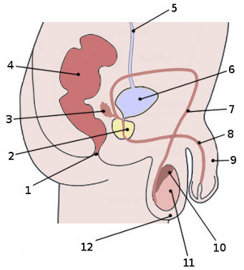

Name the following structures. (6 marks)

1 _________________________________________

3 _________________________________________

7 _________________________________________

8 _________________________________________

10 _________________________________________

11 ________________________________________

4

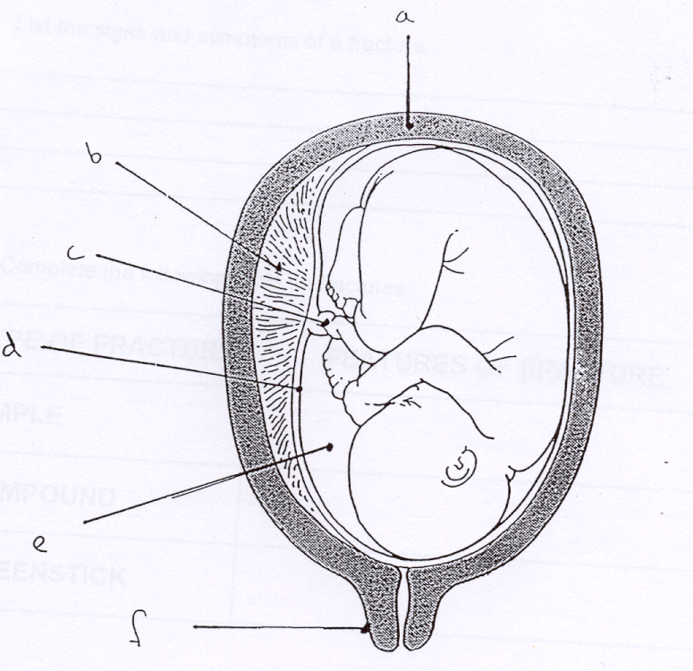

1. Complete the labels on the diagram above

A __________________________

B __________________________ E _____________________

C __________________________

(4 marks)

ii) In which period of pregnancy is the infant? (0-3 months, 3-6 months, 6-9 months)

______________________________________________ (1 mark)

* 1. Give a reasons for your answer (1 mark)

______________________________________________________________

______________________________________________________________

5. Infants are born with a number of reflex movements. Give an example of two reflexes and explain how they aid an infants chance of survival. (4 marks)

1.

2.

6. List 3 milestones that will occur in the first 3 months of a child’s development.

(3 marks)

1

2

3

G2HBY Task 5:

SCORES:

MC: /15

SA: /25

TOTAL: /40

_______ %

**NAME:_____________________________**

**TEACHER:__________________________**

**DATE:______________________________**

**Section A: Multiple choice (15 Marks)**

Answer all questions by circling the most correct answer on the multiple choice answer sheet.

1. a b c d 14. a b c d

2. a b c d 15. a b c d

3. a b c d

4. a b c d

5. a b c d

6. a b c d

7. a b c d

8. a b c d

9. a b c d

10. a b c d

11. a b c d

12. a b c d

13. a b c d